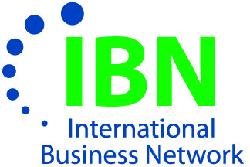

The International Business Network
Annual Post Holiday Reception

Wednesday, JANUARY 18, 2012
Embassy Suites Cleveland Rockside
5300 Rockside Woods Blvd.
Independence, OH 44131
5:30-7:30 pm

“Are You Prepared To Do Business Abroad”

Ambassador Heather Hodges
President and Ambassador-in-Residence
Cleveland Council of World Affairs

(No charge for this event-hors d’oeuvres provided-cash bar)
Please make a Reservation.
Name:__________________________________________________________________

Company/Organization: ___________________________________________________

Address: ________________________________________________________________

Phone: _______________ Fax: _________________ E-Mail: ______________________

Number in Party______________________

Please reply to:
The Northeast Ohio International Business Network
1120 Chester Avenue, Suite 470, Cleveland, Ohio 44114-3514
Phone: 216-771-1200 Fax: 216-696-2582 e-mail: admin@neoibn.org

